LICENSING AGREEMENT

Mike Sibley Fine Art, Licensor, Greenfields House, Sessay, Thirsk, N Yorks., YO7 3ND, England and ********* enter into a licensing agreement dated ****** on designs the copyright of which is held by Mike Sibley

The licensor gives permission to the licensee to produce and sell **** bearing images from original studies by Mike Sibley as listed in Appendix 1. This shall be an exclusive license for such use within *********

The licensee shall pay to the licensor a fee of £**** sterling for each image. The payment is to be made prior to any production and sales of the items.

Should, subsequently, further items be licensed, or licenses sought for other uses of the supplied images, the licensing fee shall be of £**** GBP sterling per image.

The license shall be granted for each image for a period of five years from the date of purchase of a license of a given image.

Mike Sibley Fine Art has the right to approve the image quality of each subject prior to production being implemented

Signed the day and year first above written

Michael John Sibley ……………………..
Mike Sibley Fine Art [COMPANY NAME]

30 September 2xxx

Licensing Agreement, between Mike Sibley Fine Art and XXX Creative World Ltd.

Appendix 1

Our Ref Subject

B6 Yellow Labrador

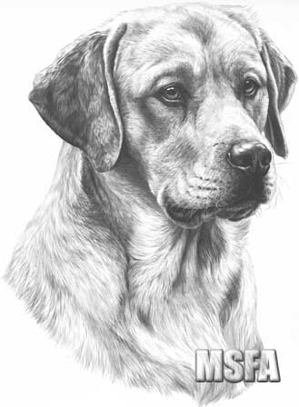

Renewal of this license at the time of termination will be offered to XXX Creative World Ltd. before being offered elsewhere.

